TEAM 10

Software Requirements Specification (SRS)
Project: Vehicle Parking System
Team:10
Version: 1.0
Authors: BR Manasi (PES2UG24CS104)
BR Manavi(PES2UG24CS105)
B Meghana (PES2UG24CS103)
B Sanjana(PES2UG24CS106)
Date: 02-09-2026
Status: Draft

Revision history
Version | Date | Authors | Change summary | Approval
1.0 | 02-09-2026 | MANASI,MANAVI,MEGHANA,SANJANA | Initial SRS draft

Approvals
Role | Name | Signature / Email | Date
Course Coordinator

Table of Contents
1. Introduction
2. Overall description
3. External interface requirements
4. System features (detailed)
5. Non-functional requirements (detailed)
6. Quality attributes & Acceptance tests
7. System models and diagrams
8. Requirements Traceability Matrix (RTM)

1. Introduction

1.1 Purpose
This document is a Software Requirements Specification (SRS) for the Vehicle Parking System (VPS), a system for managing parking slots and vehicle tracking. It defines the functional and non-functional requirements, interfaces, and verification criteria intended for developers, evaluators, and project stakeholders.

1.2 Scope
The system covers registration and authentication of users, search and reservation of parking slots, vehicle entry/exit logging and real-time occupancy tracking, payment and billing for parking usage, administrative management of parking lots and slots, and reporting/notifications. The proposed technology stack is JavaScript (MERN Stack) or Python (Flask/Django) for the backend and web application. Excludes physical construction of parking infrastructure and integration with unrelated third-party municipal traffic systems.

1.3 Audience
Developers, QA Engineers, System Integrators, Parking Facility Operators, and Assessment Evaluators.

1.4 Definitions
List of acronyms: VPS (Vehicle Parking System), UI (User Interface), API (Application Programming Interface), ANPR (Automatic Number Plate Recognition), IoT (Internet of Things), JWT (JSON Web Token), REST (Representational State Transfer), DB (Database), OTP (One-Time Password), TLS (Transport Layer Security).

2. Overall description

2.1 Product perspective
The Vehicle Parking System is a web (and optionally mobile) application that allows drivers to locate, reserve, and pay for parking slots, while giving operators and administrators tools to manage parking lots, monitor occupancy, and generate reports. It comprises a frontend client, a backend REST API (Node.js/Express or Python Flask/Django), a database, and optional hardware integrations (ANPR cameras, IoT slot sensors, boom barriers) for automated vehicle tracking.

2.2 Major product functions (detailed)
- User registration and authentication
- Parking slot search and real-time availability display
- Slot reservation and booking
- Vehicle entry/exit logging (manual or ANPR-based)
- Real-time occupancy tracking of parking slots
- Payment processing and billing for parking usage
- Administrative management of parking lots, slots, and pricing
- Reporting and analytics on occupancy and revenue
- Notifications (SMS/email) for booking, entry, exit, and payment events

2.3 User roles and characteristics
- Driver/Customer: basic app-usage knowledge, expects quick slot discovery and short entry/exit times.
- Parking Attendant/Operator: on-site staff who manage manual entries, overrides, and gate operation.
- Administrator: manages parking lots, slot configuration, pricing, and views reports.
- System (ANPR camera / IoT sensor): automated actor providing vehicle detection and slot-occupancy events.

2.4 Operating environment
Web browser client (responsive UI) for customers and administrators; optional mobile app. Backend hosted on a cloud or on-premise server (Node.js/Express or Python Flask/Django) with a relational or document database (e.g., MongoDB or PostgreSQL). Optional on-site hardware: ANPR cameras, IoT occupancy sensors, and boom barrier controllers, connected over a local network.

2.5 Constraints
Must be implemented using the JavaScript (MERN Stack) or Python (Flask/Django) technology stack. Must support real-time slot-availability updates. Must protect personally identifiable information (user details, vehicle registration numbers) in line with applicable data-protection practices. Payment handling must use a third-party payment gateway rather than storing raw card data. Delivered within an academic project timeline with a small development team.

3. External interface requirements

3.1 User interfaces
Primary UI: responsive web application with a clear menu structure for search, booking, and payment. Kiosk-style touch UI at entry/exit gates for attendants. Accessibility: screen-reader friendly prompts and high-contrast mode for visually impaired users.

3.2 Hardware interfaces
- ANPR camera / barcode-QR scanner at entry and exit gates (optional automated mode)
- Boom barrier / gate controller
- IoT slot-occupancy sensors (optional)
- Receipt/ticket printer
- Status display board / LEDs showing available slots

3.3 Software interfaces
- Backend REST API (Node.js/Express or Python Flask/Django) for all client-server communication
- Database service (MongoDB or PostgreSQL) for persistence
- Payment gateway API (e.g., Razorpay/Stripe) for transaction processing
- SMS/Email notification API for alerts and receipts
- Maps/geolocation API for directing users to the nearest available lot

3.4 Communications
- HTTPS with TLS 1.2+ enforced for all client-server and third-party API communication
- REST/JSON for standard requests; WebSocket (or polling) for real-time slot-availability updates
- Retry/backoff strategy for transient failures in payment and notification calls
[Note: overall this project defines 26 Functional Requirements, 5 Non-Functional Requirements, 3 security objectives, and 5 security requirements, satisfying the minimum of 15 FRs, 5 NFRs, 2 security objectives, and 5 security requirements.]

4. System features
Each requirement below includes acceptance criteria and a reference test case. IDs follow VPS-F-###.

4.1 User Registration & Authentication
Description: Register, authenticate, and manage roles for Drivers, Attendants, and Administrators.
Req ID | Requirement (shall...) | Type | Priority | Source/Stakeholder | Acceptance criteria / Test case ref | Comments / Dependencies
VPS-F-001 | The system shall allow a new user to register with name, email/phone, and password. | Functional | High | Customer | AC-VPS-F-001: Valid registration data creates a new account. Test: TC-Auth-01 | Requires DB, email/OTP service
VPS-F-002 | The system shall authenticate registered users via email/phone and password before granting access to booking features. | Functional | High | Customer | AC-VPS-F-002: Correct credentials create an authenticated session (JWT). Test: TC-Auth-02 | Requires Auth API
VPS-F-003 | The system shall allow password reset via OTP sent to registered email/phone. | Functional | Medium | Customer | AC-VPS-F-003: Valid OTP allows password reset within 10 minutes. Test: TC-Auth-03 | Requires OTP/notification service
VPS-F-004 | The system shall lock a user account after 5 consecutive failed login attempts and notify the user. | Functional | High | Security | AC-VPS-F-004: After 5 failures, further attempts are blocked for 15 minutes. Test: TC-Auth-04 | Audit review required
VPS-F-005 | The system shall support role-based login for Driver, Attendant, and Administrator with role-specific dashboards. | Functional | High | Operations | AC-VPS-F-005: Each role is redirected to its designated dashboard after login. Test: TC-Auth-05 | Requires RBAC module

4.2 Slot Search & Reservation
Description: Enable users to find, view, and reserve available parking slots in real time.
Req ID | Requirement (shall...) | Type | Priority | Source/Stakeholder | Acceptance criteria / Test case ref | Comments / Dependencies
VPS-F-010 | The system shall display real-time availability of parking slots for a selected lot. | Functional | High | Customer | AC-VPS-F-010: Availability count matches current occupancy within 5 seconds of a change. Test: TC-Slot-01 | Requires real-time updates
VPS-F-011 | The system shall allow a user to search for parking lots by location and filter by price/availability. | Functional | High | Customer | AC-VPS-F-011: Search returns lots matching filters, sorted by distance. Test: TC-Slot-02 | Requires Maps API
VPS-F-012 | The system shall allow a user to reserve a specific slot for a chosen date/time window. | Functional | High | Customer | AC-VPS-F-012: Reservation is confirmed and slot marked unavailable to others. Test: TC-Slot-03 | Requires booking engine
VPS-F-013 | The system shall allow a user to cancel a reservation before the scheduled arrival time. | Functional | Medium | Customer | AC-VPS-F-013: Cancelled slot becomes available again within 1 minute. Test: TC-Slot-04 | Cancellation policy required
VPS-F-014 | The system shall prevent double-booking of the same slot for overlapping time windows. | Functional | High | Business | AC-VPS-F-014: Concurrent booking attempts for the same slot/time are rejected for all but the first. Test: TC-Slot-05 | Requires concurrency control

4.3 Vehicle Entry/Exit & Real-Time Tracking
Requirements: The system shall log vehicle entry and exit (manually by attendant or automatically via ANPR), match entries against active reservations, track occupied/available slots in real time, and raise an alert for unregistered/unauthorized vehicles. IDs: VPS-F-020..VPS-F-025.

4.4 Payment & Billing
Requirements: The system shall calculate parking fees based on duration and rate, process payments via an integrated payment gateway, generate digital receipts, and support refunds for cancelled reservations. IDs: VPS-F-030..VPS-F-032.

4.5 Admin & Parking Lot Management
Requirements: The system shall allow administrators to create/update parking lots and slots, configure pricing rules, view live occupancy dashboards, and manage attendant accounts. IDs: VPS-F-040..VPS-F-043.

4.6 Notifications & Reporting
Requirements: The system shall send booking confirmation, entry/exit, and payment notifications via SMS/email, and generate periodic occupancy and revenue reports for administrators. IDs: VPS-F-050..VPS-F-052.

5. Non-functional requirements (detailed)
NFRs below are measurable and tied to test plans. IDs VPS-NF-###.
Req ID | Requirement | Category | Priority | Acceptance criteria / Measurement
VPS-NF-001 | End-to-end response time for slot search and booking confirmation shall be ≤ 3 seconds for 90% of requests under normal load. | Performance | High | 90th percentile ≤ 3s in production-like test. Test: TC-Perf-01
VPS-NF-002 | The system shall provide 99.5% availability monthly, excluding scheduled maintenance windows. | Reliability | High | Uptime reports show ≥ 99.5% per month. Test: Ops reports
VPS-NF-003 | The system shall support at least 500 concurrent users without degradation of core booking functions. | Scalability | Medium | Load test with 500 concurrent users passes with response times within target. Test: TC-Perf-02
VPS-NF-004 | All sensitive user and payment data must comply with applicable data-protection practices; raw card data must never be stored by the system. | Security/Compliance | High | Security review confirms no raw card data storage. Test: TC-Sec-01
VPS-NF-005 | The system shall support accessibility features (screen reader, high-contrast mode) conforming to WCAG 2.1 AA where applicable. | Usability/Accessibility | Medium | Accessibility audit pass. Test: TC-UX-01

5.1 Security

5.1.1 Security Objectives
- Protect user personal data (name, contact details, vehicle registration number) from unauthorized access or disclosure.
- Ensure the integrity of parking-slot availability, reservation, and transaction data against tampering.
- Ensure only authenticated, authorized users can access administrative and attendant functions.
- 5.1.2 Security Requirements
Req ID | Requirement (shall...) | Type | Priority | Acceptance criteria / Test case ref
VPS-SR-001 | TLS 1.2+ shall be mandatory for all network connections between client, server, and third-party APIs. | Security | High | AC-VPS-SR-001: All endpoints reject non-TLS connections. Test: TC-Sec-02
VPS-SR-002 | User passwords shall be stored using a salted one-way hash (e.g., bcrypt); plaintext passwords shall never be persisted. | Security | High | AC-VPS-SR-002: DB inspection shows only hashed passwords. Test: TC-Sec-03
VPS-SR-003 | The system shall enforce role-based access control (RBAC) restricting admin and attendant functions to authorized roles. | Security | High | AC-VPS-SR-003: Unauthorized role attempting a restricted action receives HTTP 403. Test: TC-Sec-04
VPS-SR-004 | Payment card data shall not be stored by the system; payment processing shall be delegated to a PCI-DSS compliant gateway using tokenization. | Security | High | AC-VPS-SR-004: Payment flow review confirms no card data reaches application DB. Test: TC-Sec-05
VPS-SR-005 | The system shall maintain an audit log of administrative actions (lot/slot changes, account changes) with timestamp and actor identity. | Security | Medium | AC-VPS-SR-005: Audit log entries created for sampled admin actions. Test: TC-Sec-06

6. Quality attributes & Acceptance tests
- Exit criteria for acceptance: All high-priority functional requirements implemented and verified, no critical NFR failures, and RTM shows all listed test cases passed.
- Acceptance test suites: Authentication, Slot Search & Reservation, Entry/Exit Tracking, Payment & Billing, Admin Management, Performance, and Security tests.

7. System models and diagrams

7.1 UML Use-Case diagram
Two use case diagrams are provided below: one for the Driver/Customer actor and one for the Administrator/Attendant actors.

Driver / Customer use case diagram
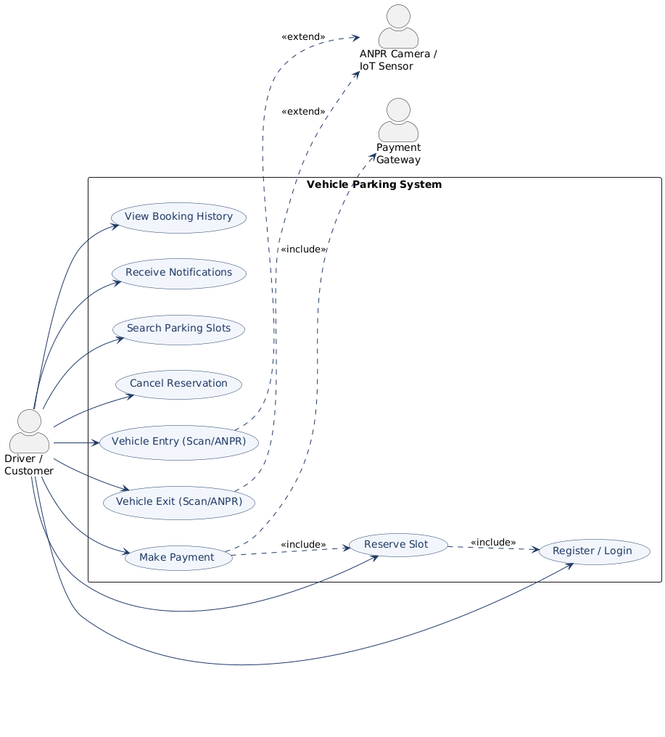

Administrator / Attendant use case diagram
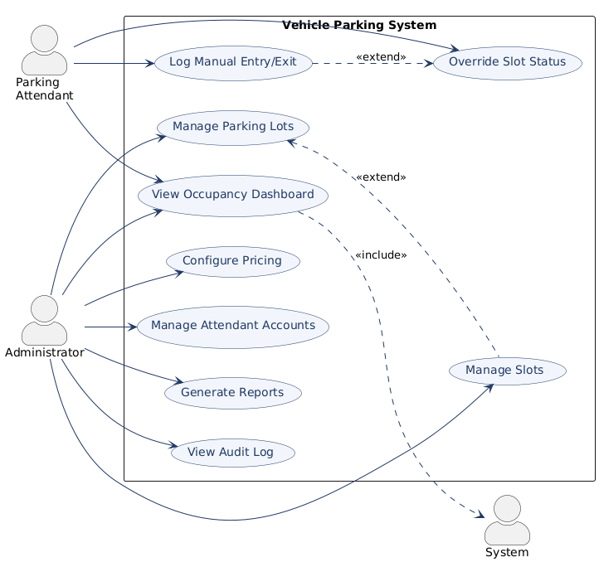

8. Requirements Traceability Matrix (RTM)
Req ID | Requirement (short) | Section ref / Design Spec | Module | Test case(s) | Status (N/P/A) | Comments
VPS-F-001 | User registration | 4.1 / DS-Auth-01 | AuthModule | TC-Auth-01 | N
VPS-F-010 | Display slot availability | 4.2 / DS-Slot-01 | SlotModule | TC-Slot-01 | N
VPS-F-012 | Reserve a slot | 4.2 / DS-Slot-02 | BookingModule | TC-Slot-03 | N
VPS-NF-001 | Response time target | 5 / DS-Perf-01 | WebUI / API | TC-Perf-01 | N
VPS-SR-001 | TLS enforcement | 5.1.2 / DS-Sec-01 | Infra | TC-Sec-02 | N

